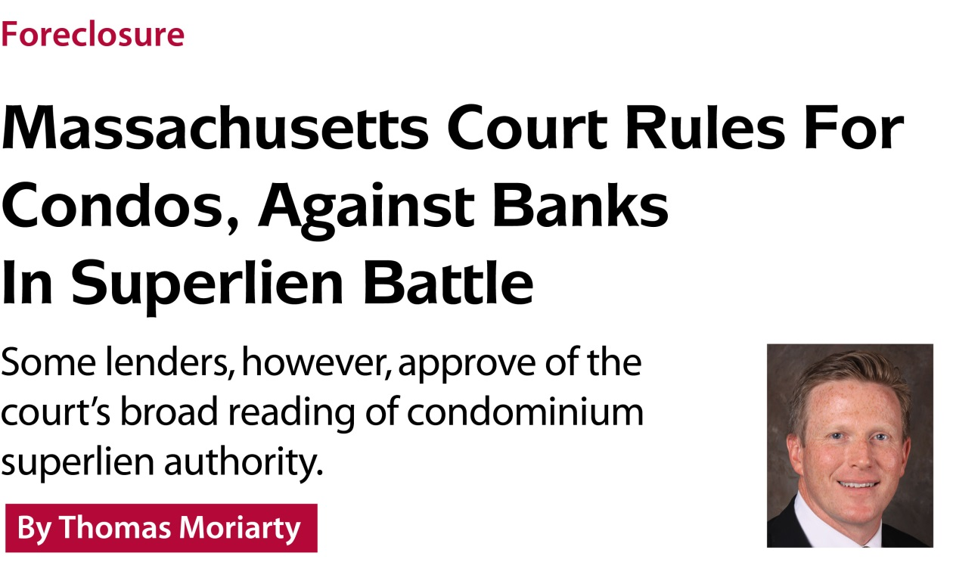
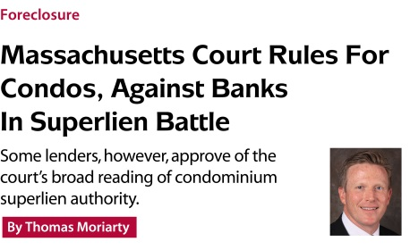
“Those who can’t remember the past are doomed to repeat it.” That oft-repeated and often-needed reminder comes to mind following a recent decision by the Massachusetts Supreme Judicial Court (SJC) affirming the ability of condominium associations to establish multiple contemporaneous priority liens to collect unpaid monthly common fees.
The history of the “rolling lien,” and the Massachusetts superlien statute on which it is based, is instructive.
The state legislature enacted the superlien statute in 1993 in response to what lawmakers described at the time as a “serious public emergency.” A severe economic downturn in the late 1980s and early 1990s had left many condominium owners without jobs and unable to make their mortgage payments or pay their share of common area expenses. Because outstanding mortgages often exceeded increasingly depressed property values, condominium associations, standing behind mortgage lenders in the priority line, frequently left foreclosure sales empty-handed. Unable to collect the payments they were owed, the associations lacked the revenue they needed to provide essential services to owners and maintain the condominium common areas for which they were responsible.
Facing financial pressures themselves, some owners were unable to fill the financial gap created by the delinquencies; others, distressed by the decline in maintenance and property values, decided it wasn’t in their interest to put money into a declining asset and stopped paying their common area fees, as well. The result was a vicious, destructive cycle creating the “public emergency” to which the legislature responded with the superlien, giving associations the ability to collect six months of unpaid assessments ahead of the first mortgage lender.
Condominium associations interpreted the superlien statute to authorize “rolling liens” covering multiple six-month periods, enabling them to collect delinquent payments that accumulated during what could be an extended foreclosure process. Thousands of trial court decisions over more than two decades affirmed that interpretation. So, it was unexpected and unsettling when two appellate-level courts rejected it in the course of a seven-year legal battle culminating in the SJC’s decision (Drummer Boy Home Association Inc. vs. Britton).

The legal battle
The underlying dispute began when the Brittons, owners of a unit in this Lexington, Mass., condominium community, withheld their monthly common area fees to protest fines levied on them for violations of parking rules with which they disagreed. The condo association filed three successive six-month liens to recover the delinquent payments that accumulated during the prolonged dispute and sued to enforce the liens.
The district court ruled that the association could collect only the six months of delinquent payments and legal fees covered by the first lien because, in the court’s view, the Massachusetts condominium statute didn’t permit successive priority liens. When the appellate division of the district court and the appeals court both upheld that decision, the association sought further review in the SJC.
The Brittons represented themselves in the appeal, supported by amicus briefs from the Bank of America and the Federal Housing Finance Agency (FHFA), primary regulator for Fannie Mae and Freddie Mac, which has been leading efforts to challenge the condominium priority lien in other states.
The FHFA’s brief summarized the two primary arguments for its position that the Massachusetts superlien statute does not and should not permit rolling liens:
1. The legislature intended to permit only one priority lien covering the six months preceding the lien’s filing, and the “plain wording” of the statute reflects that intent.
2. The enforcement of “rolling liens” will have dire consequences for condominium lenders, condominium communities and condominium owners.

A singular argument
On the first point, the FHFA argued that the legislature intentionally carved out a “narrow” exception to the normal priority structure to preserve the balance it sought to strike between the condo association’s need to collect revenues and the need of lenders to protect their security interests in the loans they originated. Rolling liens upset that intended balance, the FHFA said, by allowing associations “to expand the super priority period of their assessment ad infinitum.” Had the legislature intended to create an unlimited lien, the FHFA argued, it would have done so “explicitly,” rather than indirectly, by allowing associations to file “successive, docket-clogging lawsuits.”
Both sides in this case argued that the “plain meaning” of the statute supported their differing interpretations of it. The differences turned, in part, on the statute’s references to “liens” - plural. The FHFA dismissed what it termed the “one-time use” of the plural as insufficient to support the association’s position - that the legislature anticipated multiple liens. And where the statute does mention liens, the FHFA said, it is referring to liens against all units collectively, not to multiple liens against a single unit.
We pointed out that the statute includes many references - not just one - to liens, including this one describing an association’s actions to enforce its priority liens “against a particular unit.” We read that plain language as evidence that lawmakers did, in fact, anticipate that associations would file multiple liens against a single unit - and the SJC agreed.
The court acknowledged that the legislation does not specifically describe rolling liens. But, given the stated intent of lawmakers (to address a “serious public emergency”), the court said, it is reasonable to conclude that they would view delinquencies that accumulate after a priority lien has been filed “as an ongoing problem necessitating more than the heretofore limited remedy of one lien for six months’ worth of common expenses.”
A 1998 amendment to the statute supports that interpretation, the court said. The amendment details the steps lenders can take to preserve their lien priorities - by paying off the owners’ delinquent payments and assuming responsibility for future delinquencies.
Construing the statute to permit only a single six-month priority lien, the court said, would make this process “inconsequential ... There would be little reason for a first mortgagee to assume responsibility for the payment of a unit owner’s future common expenses if the condominium association were limited to one six-month period of lien priority,” the court reasoned, because future common expenses would always be subordinate to the first mortgage. The mechanism the statute establishes for protecting a lender’s priority position “reflects an awareness by the Legislature that the statute permits an organization of unit owners to establish and enforce multiple contemporaneous priority liens ... ” the court concluded.

Dire consequences
The FHFA argued that “dire consequences” would result if condominium associations were allowed to pursue multiple, successive liens against delinquent owners. Affirming that interpretation of the law, the FHFA said, would “increase lending costs to mortgagors, discourage the extension of credit to potential purchasers of affected condominiums and depress condominium prices.” The overall result, the FHFA argued, would be to “dampen mortgage lending and damage the recovery of the [Massachusetts] housing market.”
The facts don’t support that argument. As we pointed out in our reply brief, there is no evidence that rolling liens have had any adverse effects in Massachusetts. On the contrary, although the rolling lien has been recognized almost since the priority lien was enacted 20 years ago, the brief notes, “for more than two decades, there has been substantial condominium development and robust condominium lending in the Commonwealth ... [and] there is no reason to believe [the recognition of multiple contemporaneous priority liens] will have any adverse impacts on lending [in the future].”
Probably the strongest rebuttal of the FHFA’s warning about rolling liens came from lenders that are supposedly threatened by them. An amicus brief joined by five Massachusetts lenders notes that the ability to pursue multiple liens ensures that delinquencies will not deprive condo associations of the revenue on which they rely to maintain their communities. And that assurance has given lenders the confidence they need to provide loans to condominium associations, which are secured by the fees associations collect from owners. Before the enactment of the superlien, the bankers’ brief notes, association lending was virtually nonexistent. Today, lenders have about $229 million in loans outstanding to approximately 721 Massachusetts condominium associations.
“Simply put, other than in unusual situations, without a priority (over unit first mortgages) that covers multiple lien periods contemporaneously, association loans would not exist as they have for more than 20 years,” the bankers note in their brief. If associations lost their ability to pursue rolling liens, they warn, “the association lending business would largely evaporate.”
Rolling liens also protect the interests of first mortgage lenders, the bankers note, because ensuring the financial health of community associations protects the value of the units securing condominium loans. The existing statutory scheme “as it has been interpreted up to now is working for everyone,” the bankers argue. “It protects the interests of condominium associations, association lenders and first mortgage lenders on condominium units.”
The FHFA argued that the possibility that a lender’s first mortgage could be erased completely by a condominium association’s priority liens creates an untenable risk for lenders. The SJC was not sympathetic. Although priority liens might indeed eliminate a lender’s security interests, the court agreed, “it is well within the control of a first mortgagee to avert the establishment of such liens in the first instance” by following the procedures outlined in the superlien statute and paying the delinquent assessments.

A continuing threat
The court’s decision brings welcome relief to Massachusetts condominium associations, which, for the past two years (since the appellate decisions rejecting rolling liens), could have only one six-month priority lien in place at a time. Given that restriction, we had been advising our clients to turn over delinquent accounts for collection as soon as they reached the 60-days-past-due mark. With rolling liens reaffirmed, associations must still be diligent, but they no longer have to be frantic; they can take more time - up to 90 days - to try to resolve the delinquency before pursuing legal action. That flexibility benefits financially ailing owners, as well as associations.
There is no question that the Drummer Boy decision represents a huge victory for condominium associations, condominium owners and (though some may not admit it) condominium lenders in Massachusetts. But, although the decision has seemingly secured the superlien in Massachusetts, it has not ended the threat in other states, where large national lenders and the FHFA are challenging the priority lien in court actions and legislative lobbying campaigns.
If successful, these efforts to weaken the superlien or eliminate it entirely would return the condominium world to the dark ages, when economic downturns threatened the viability of condominium communities, depressed condominium values, and undermined the financial interests of condominium owners and mortgage lenders. The lenders that defended the superlien in Drummer Boy remembered that history vividly, as did the SJC in its decision to uphold rolling liens. We hope the FHFA and others challenging the superlien will recall this dismal history, as well, because that is the only way to avoid repeating it.

Thomas Moriarty is a partner in the firm Marcus Errico Emmer & Brooks, where he heads up the litigation department. He specializes in condominium law, representing clients in Massachusetts, Rhode Island and New Hampshire, and he represented Drummer Boy in its recent successful appeal. He can be reached at tmoriarty@meeb.com.

