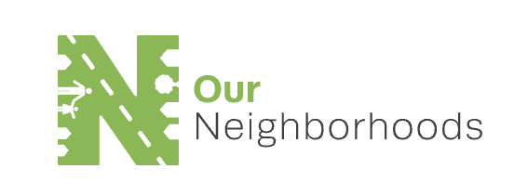

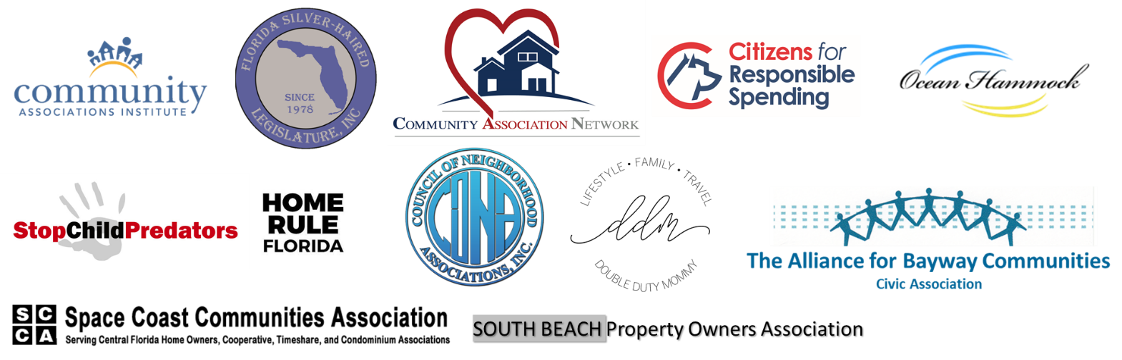

FOR IMMEDIATE RELEASE
March 13, 2019

Stacie Rumenap
srumenap@stopchildpredators.org

Local Leaders and Child Safety Advocates Launch “Our Neighborhoods” Coalition
To Urge Florida Leaders to Regulate Short-Term Rentals In Florida
Representing more than seven million Florida homeowners, coalition to urge state lawmakers to reject “Airbnb’s bill” limiting localities’ ability to protect neighborhoods

Tallahassee, FL – Today, Our Neighborhoods, a newly-formed coalition of Florida leaders, child safety advocates, former law enforcement officials, parents, civic leaders, housing experts and homeowner association presidents launched to provide neighborhoods across the state with one voice in addressing government leaders. The group will engage legislators at all levels of government on emerging issues that impact local communities, including fighting for legislation that would impose stronger regulations on the short-term rental industry. Combined, Our Neighborhoods represents more than seven million homeowners and stakeholders across the Sunshine State.

The group includes the Florida Silver Haired Legislature, Community Associations Institute, Community Association Network, Citizens for Responsible Spending, The Alliance for Bayway Communities, Council of Neighborhood Associations, Space Coast Communities Association, Ocean Hammock Property Owners Association, Home Rule Florida, Double Duty Mommy, Stop Child Predators, South Beach Property Owners Associations, and others.

Our Neighborhoods will focus on the ongoing influx of short-term rentals in Florida’s residential communities, protecting true home sharing of primary residences, while urging Florida legislators to stop the unregulated conversion of residential homes into short-term rentals by commercial interests. The group will call on legislators to protect the rights of cities and localities to regulate short-term rentals to protect housing, child safety and neighborhoods by opposing legislation the groups refers to as “Airbnb bills,” which includes SB 824 introduced by State Senator Manny Diaz, HB 1159 by State Representative Mike La Rosa, and HB 987 by James “J.W.” Grant.
“Whether the main focus on your neighborhood is the safety of your children, diversity, housing costs, short-term rentals or something else, we can all band together to bring these issues to our lawmakers,” said Jennifer Mercurio, Florida resident and author of Double Duty Mommy. “By forming a collective voice for these issues, we can and will help make our neighborhoods safe.”
“Local residents should have a voice in the decisions that impact their neighborhoods and our local officials should have the ability to bring those voices forward in enacting regulations that best fit the needs of their communities,” said Ernie Bach, executive director of the Florida Silver Haired Legislature. “As home to more than 3.5 million residents age 60 years or older, our state prides itself on providing a promising quality of life for retired persons. Allowing commercial investors to operate unregulated illegal hotels in residential neighborhoods and buildings does not fulfill that promise.”

“It is my hope that Florida’s legislators will protect the public from the increasing number of problems created by unregulated short-term rental operators,” stated Alan Garfinkel of the Community Association Network. “Smart regulation to protect our quality of life, neighborhoods and communities is badly needed, starting with legislative protections. My own next-door neighbor rents short-term leading to a stream of cars pulling up and cramming people into vehicles. My neighbors and I suffer while the short-term renter ignores basic permitting, sanitation, and other health and safety codes."

“Airbnb was founded on the idea of home sharing and many hosts are truly homeowners who are earning extra income,” said Barney Bishop, founder of Tallahassee-based Citizens for Responsible Spending. “However, investors and commercial operators are increasingly taking advantage of this platform to essentially operate lodging businesses in neighborhoods and local governments must have the ability to provide common-sense regulations. It is important to protect property rights, but that includes the rights of homeowners living in neighborhoods where short-term vacation rentals are operating.”

“With a revolving door of strangers coming and going from short-term rental properties, tools like sex offender lists are becoming obsolete as there is no safeguard in place to stop a child predator from renting an Airbnb property next door,” stated Stacey Rumenap, President of Stop Child Predators. “Home sharing sites like Airbnb have not done enough to combat the unacceptable actions of their hosts and guests. If they truly care about the surrounding communities and families living next to their rentals, they need to step up and enforce safeguards to keep children safe.”

About Our Neighborhoods
Our Neighborhoods is a coalition of neighbors – including child safety advocates, former law enforcement officials, parenting voices and bloggers, civic leaders, housing experts, homeowner association presidents and academics – coming together to form a collective voice to address issues impacting neighborhoods across the country.

###

